**An Android Application for Keeping Up with the Latest Headlines:**





**Team ID:**  LTVIP2023TMID08097

**Team Size:**  5

**Team Leader:**  Tumma Yogitha

**Team member:**  Rajana Hemalatha

**Team member:**  Vasarla Jahnavi

**Team member:**  Sk Chandinibegum

**Team member:**  Tadi Reena

**INTRODUCTION**

The app's main feature is displaying a list of news articles, each with a title, image, and brief description. Users can scroll through the list of articles and tap on an article to view more details. The app uses the Jetpack Compose UI toolkit to build the UI and it uses the coil library to load images. The app fetches data from a remote server using the Retrofit library and demonstrates how to use the Jetpack Compose UI toolkit for Android development.

**Architecture**

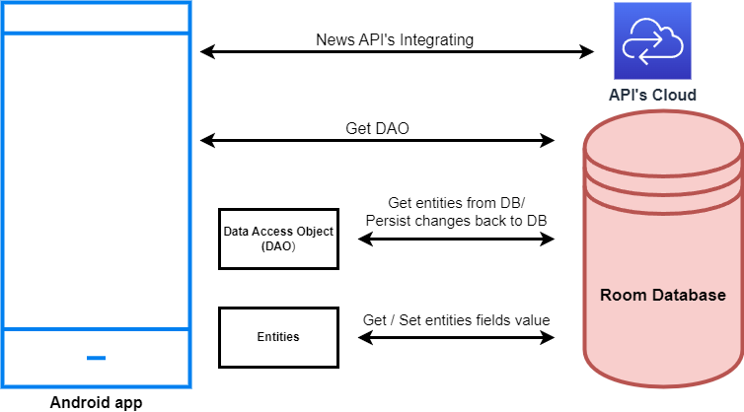

**Learning Outcomes:**

By the end of this project:

* You’ll be able to work on Android Studio and build an app.
* You’ll be able to integrate the database accordingly.
* You’ll be able to integrate the API’s accordingly.

**Project Workflow:**

* Users register into the application.
* After registration, the user logins into the application.
* User enters the main page

**Tasks:**

1. Required initial steps

2. Creating a new project.

3. Adding required dependencies.

4. Adding permissions

5. Creating the database classes.

6. Creating API Services and required classes for integrating API

7. Building application UI and connecting to database.

8. Modifying AndroidManifest.xml

9. Running the application.

**Task 1:**

Required initial steps:

<https://developer.android.com/studio/install>

**Task 2:**

Creating a new project.

Step 1: Android studio > File > New > New Project > Empty Compose Activity Step Step 2: Click on the **Next** button.

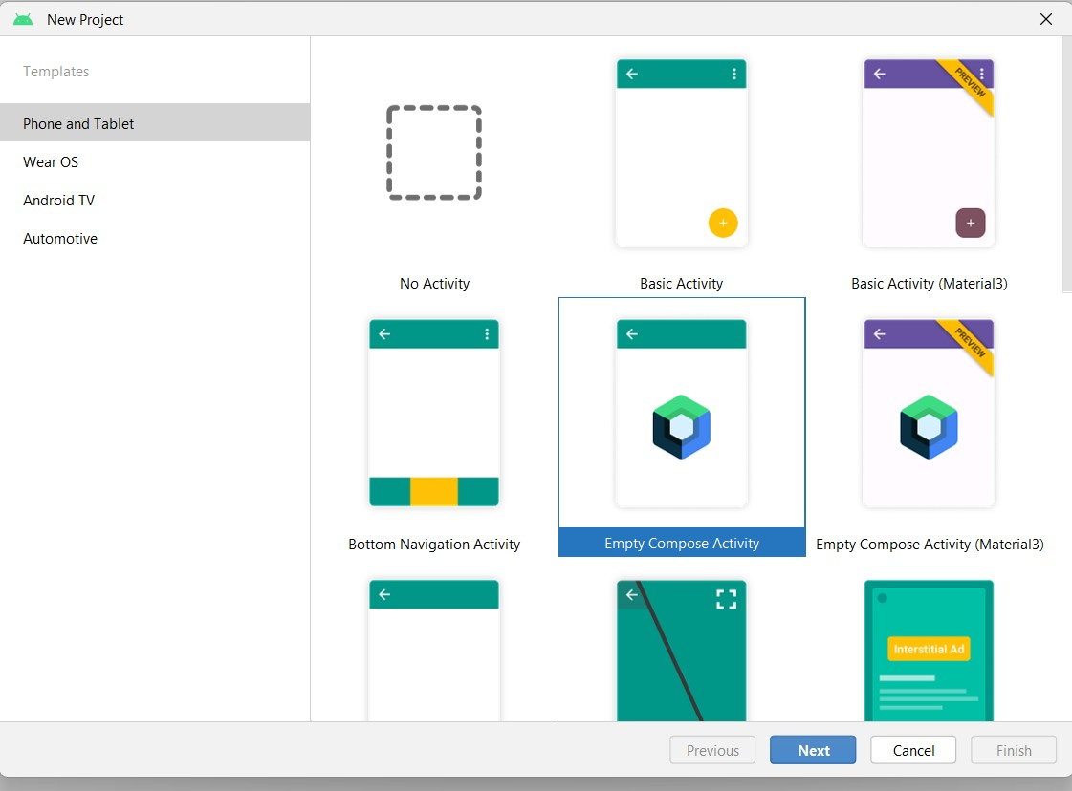

Step 3: Give a name to the new project.

Step 4: Give the Minimum SDK value

Step 5: Click Finish

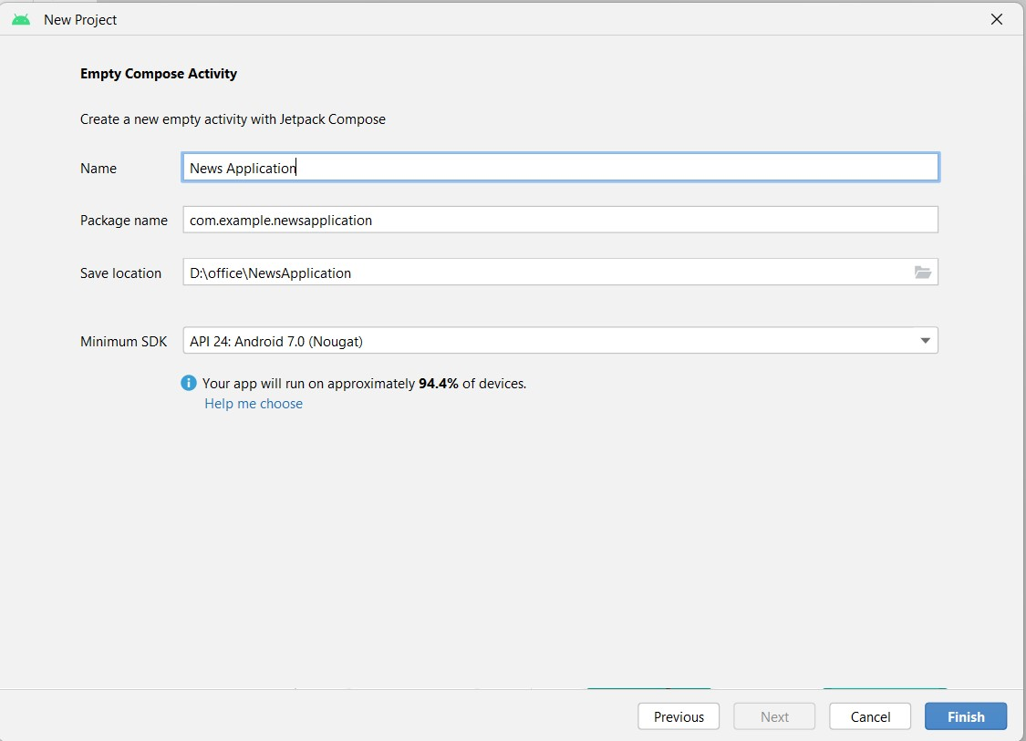

Main activity file

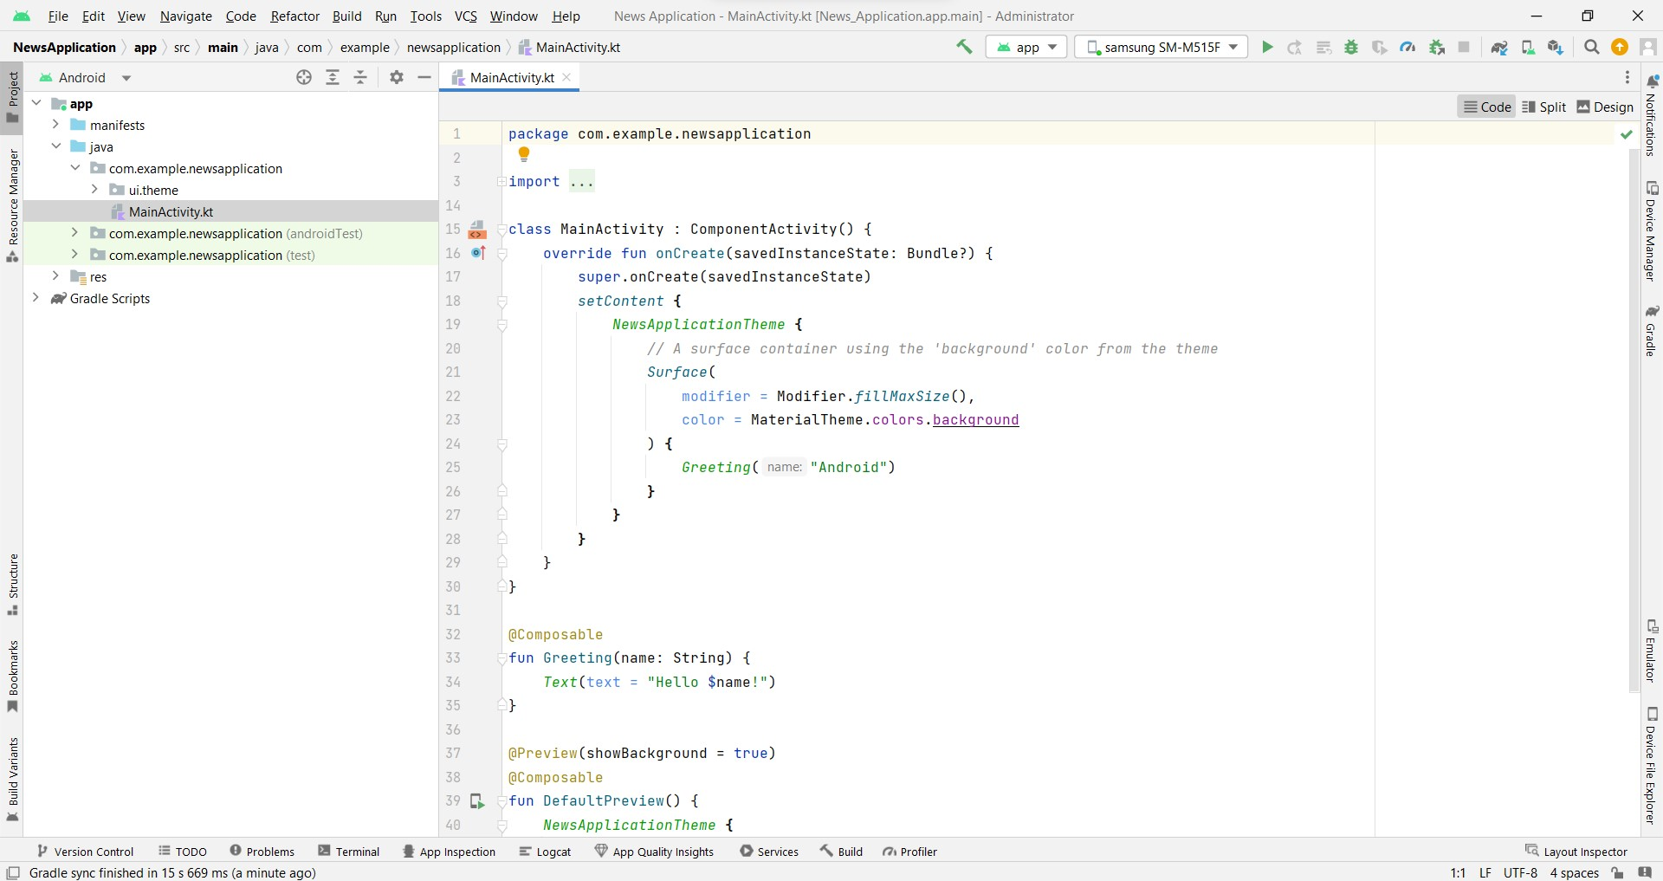

**Task 3:**

Adding required dependencies.

Step 1: Gradle scripts > build.gradle(Module :app)

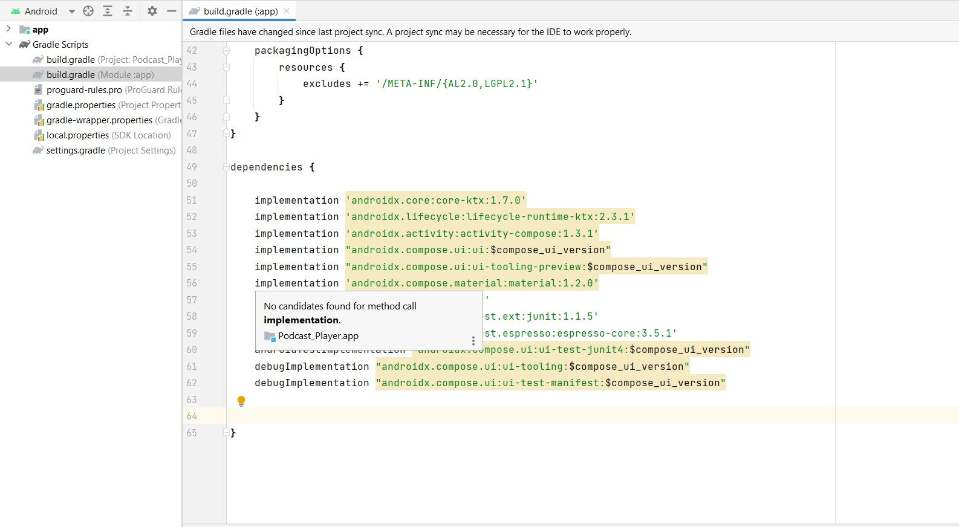

Step 2: Adding room dependencies.

Add the below code to the dependencies

*// Room Database* implementation 'androidx.room:room-common:2.5.0' implementation 'androidx.room:room-ktx:2.5.0'

Step 3: Adding Retrofit dependencies

*// Retrofit* implementation 'com.squareup.retrofit2:retrofit:2.9.0' implementation "com.squareup.okhttp3:okhttp:5.0.0-alpha.2" implementation 'com.squareup.retrofit2:converter-gson:2.9.0' Step 4: Adding Coil dependencies

implementation("io.coil-kt:coil-compose:1.4.0")

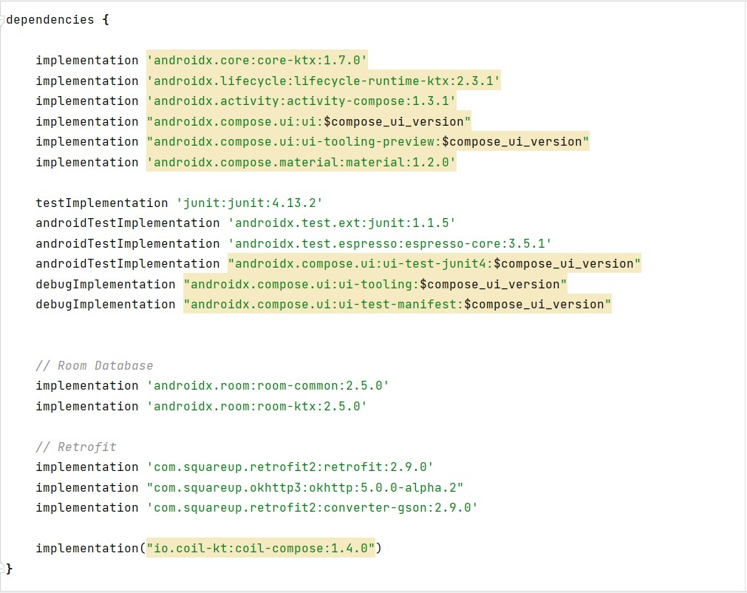

Step 5 : Click on Sync now

**Task 4:**

Adding permissions

Step 1: Open AndroidManifest.xml.

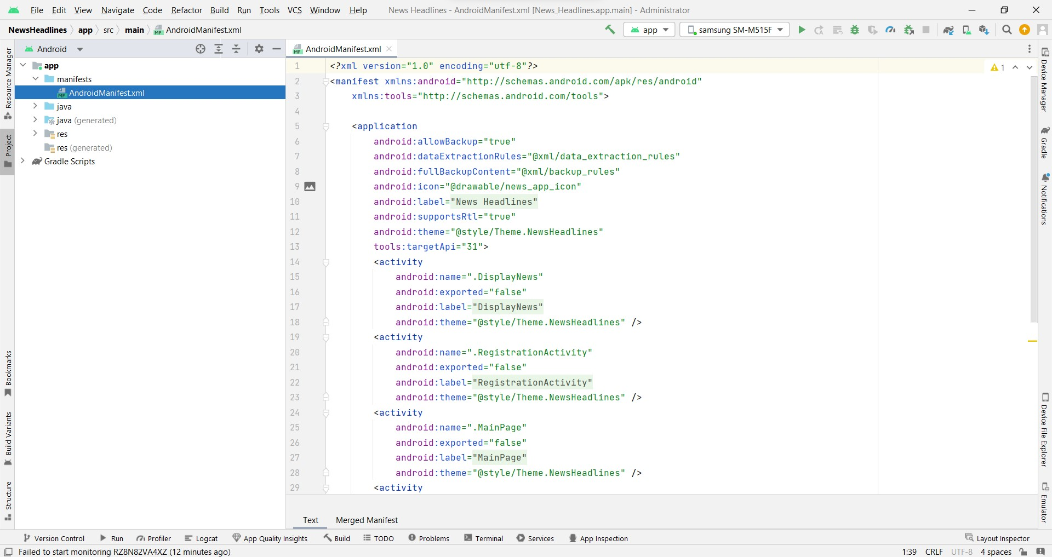

Step 2: Add permission to access wifi and the internet

*<!-- permissions-->*

<uses-permission android:name="android.permission.INTERNET"/>

<uses-permission android:name="android.permission.ACCESS_WIFI_STATE"/>

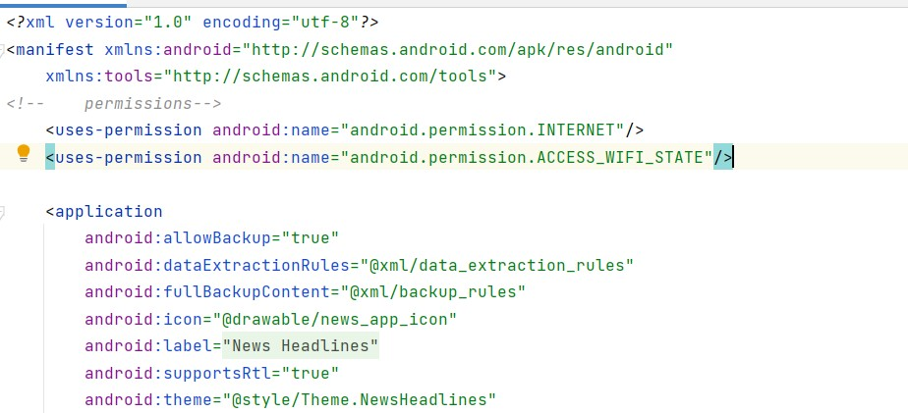

**Task 5:**

Creating the database classes.

● To learn more about Database follow this link:

[https://gorillalogic.com/blog/android-room-tutorial-simplifying-how-you-work-with-app-da ta/](https://gorillalogic.com/blog/android-room-tutorial-simplifying-how-you-work-with-app-data/)

Step 1 : Create User data class

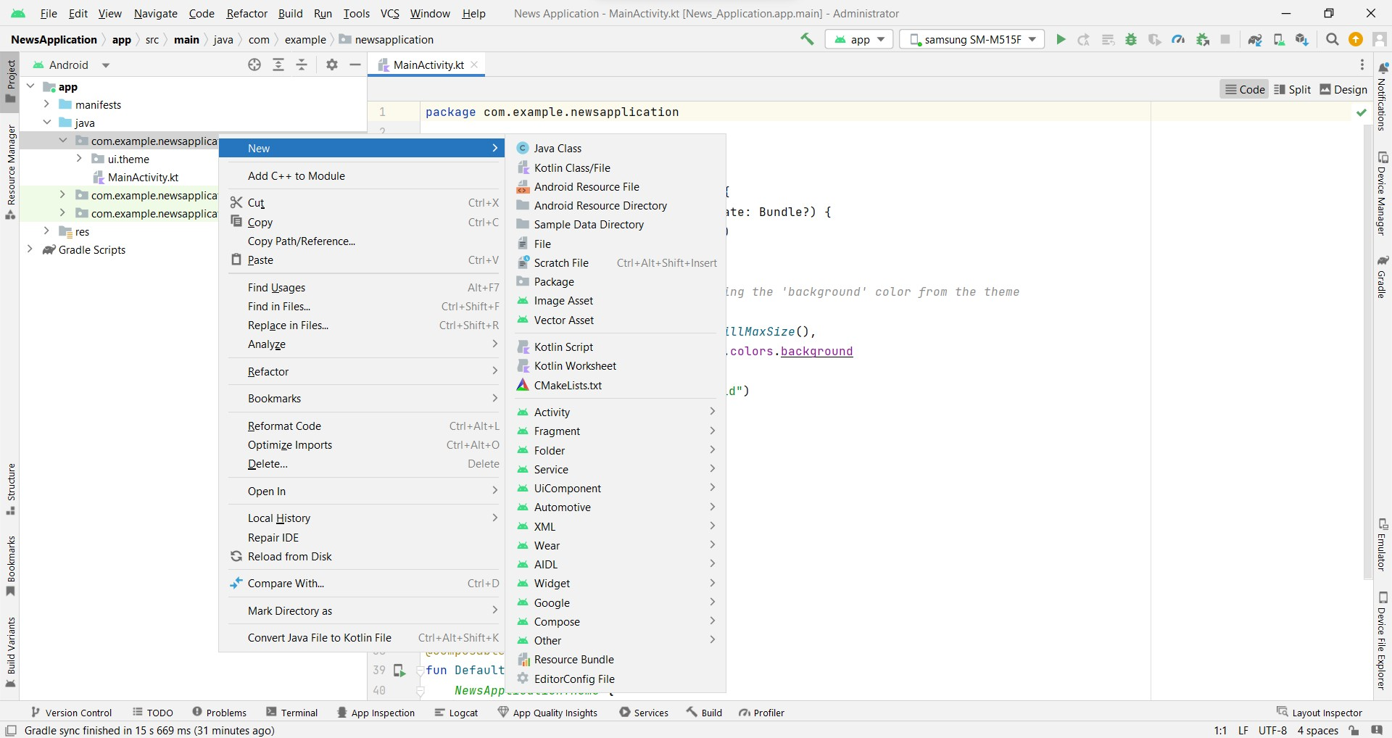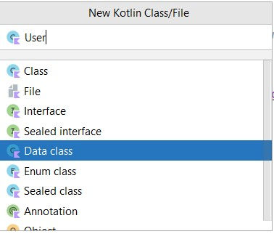

User class code:

[https://github.com/smartinternz02/NewsHeadlines/blob/main/app/src/main/java/com/exa mple/newsheadlines/User.kt](https://github.com/smartinternz02/NewsHeadlines/blob/main/app/src/main/java/com/example/newsheadlines/User.kt)

Step 2 : Create an UserDao interface



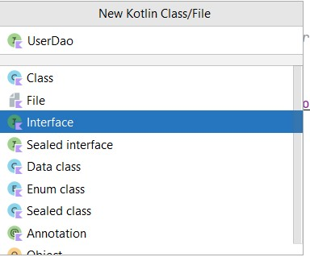

UserDao interface code:

[https://github.com/smartinternz02/NewsHeadlines/blob/main/app/src/main/java/com/exa mple/newsheadlines/UserDao.kt](https://github.com/smartinternz02/NewsHeadlines/blob/main/app/src/main/java/com/example/newsheadlines/UserDao.kt)

Step 3: Create an UserDatabase class



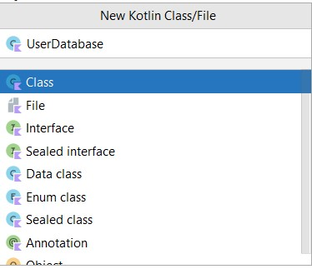

UserDatabase class code:

[https://github.com/smartinternz02/NewsHeadlines/blob/main/app/src/main/java/com/exa mple/newsheadlines/UserDatabase.kt](https://github.com/smartinternz02/NewsHeadlines/blob/main/app/src/main/java/com/example/newsheadlines/UserDatabase.kt)

Step 4: Create an UserDatabaseHelper class



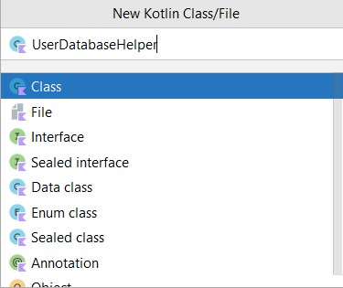

UserDatabaseHelper class code:

[https://github.com/smartinternz02/NewsHeadlines/blob/main/app/src/main/java/com/exa mple/newsheadlines/UserDatabaseHelper.kt](https://github.com/smartinternz02/NewsHeadlines/blob/main/app/src/main/java/com/example/newsheadlines/UserDatabaseHelper.kt)

**Task 6:**

Creating API Service and required classes for integrating API

Step 1: Create a API key for the required API

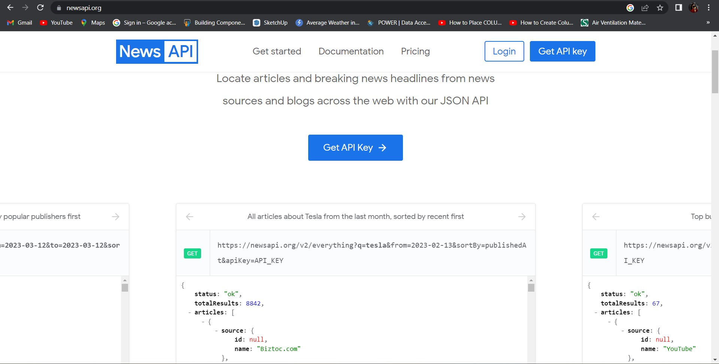

* Code which is needed to copy:

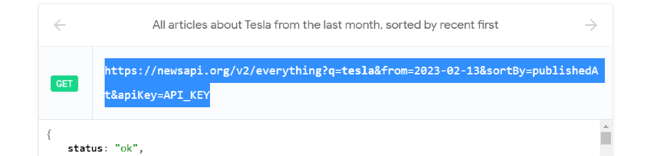

* Enter the API key at API_KEY to get the complete json file.

Json File

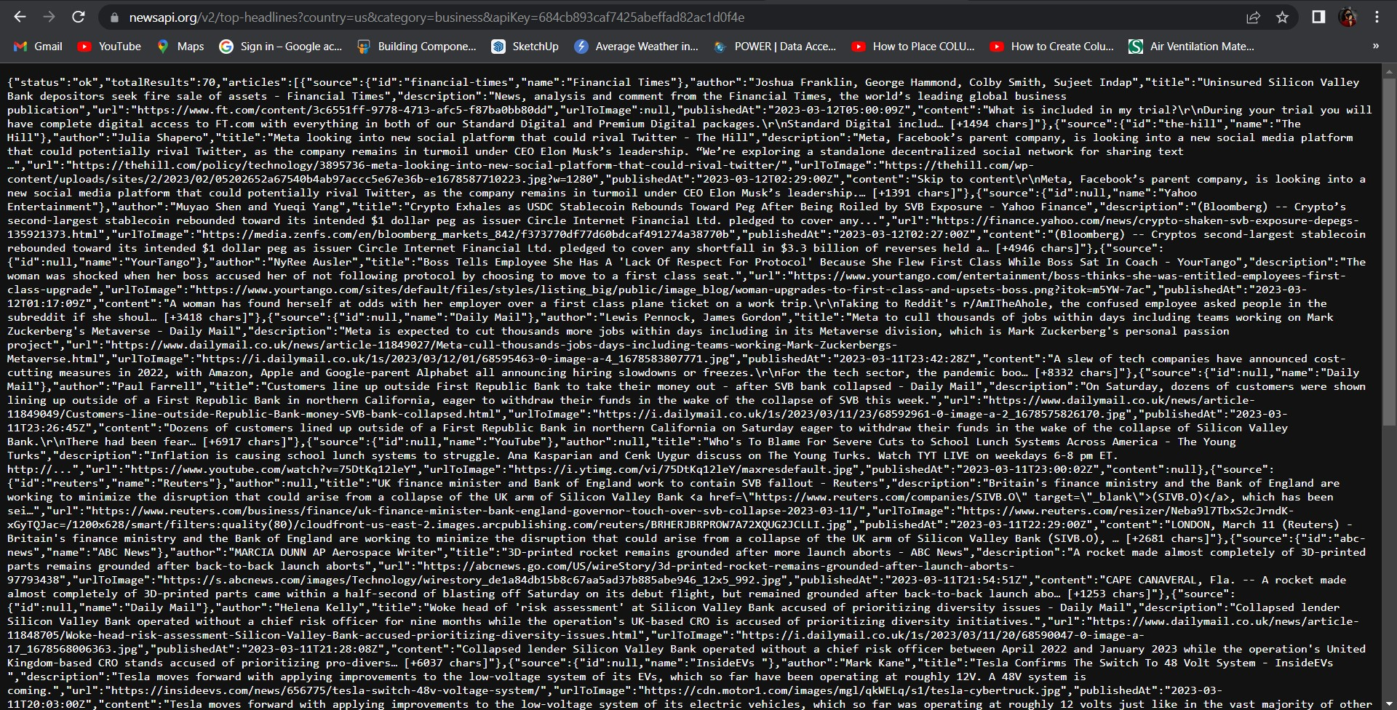

Step 2: Copy and paste the complete json file to json2kt.com

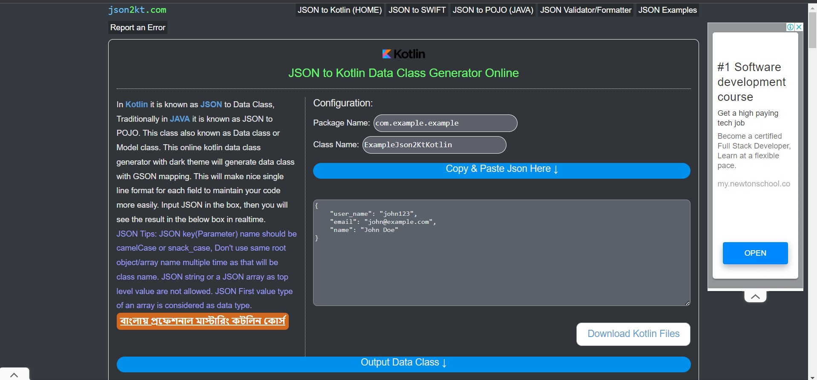

Click on Output Data class

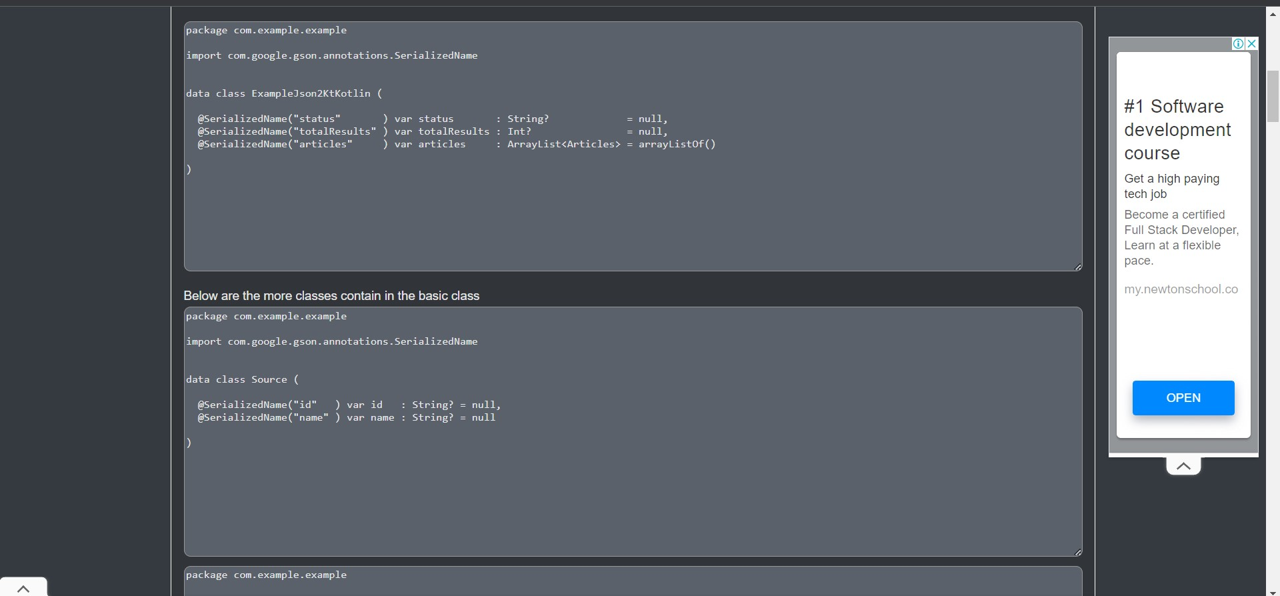

Now use this class in android studio

**Database for news integration into project**

Step 3:

Create ApiService interface

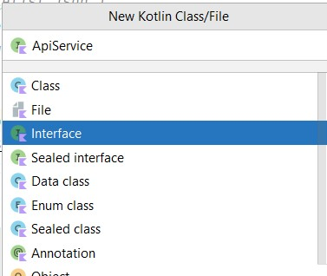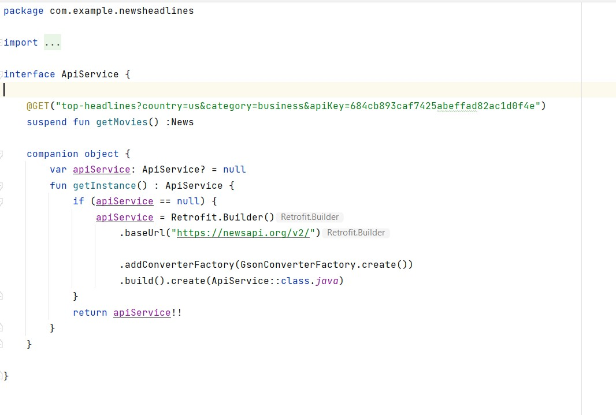

ApiService interface code: [https://github.com/smartinternz02/NewsHeadlines/tree/main/app/src/main/java/com/exa mple/newsheadlines/ApiService.kt](https://github.com/smartinternz02/NewsHeadlines/tree/main/app/src/main/java/com/example/newsheadlines/ApiService.kt)

Step 4:

Create Model data class

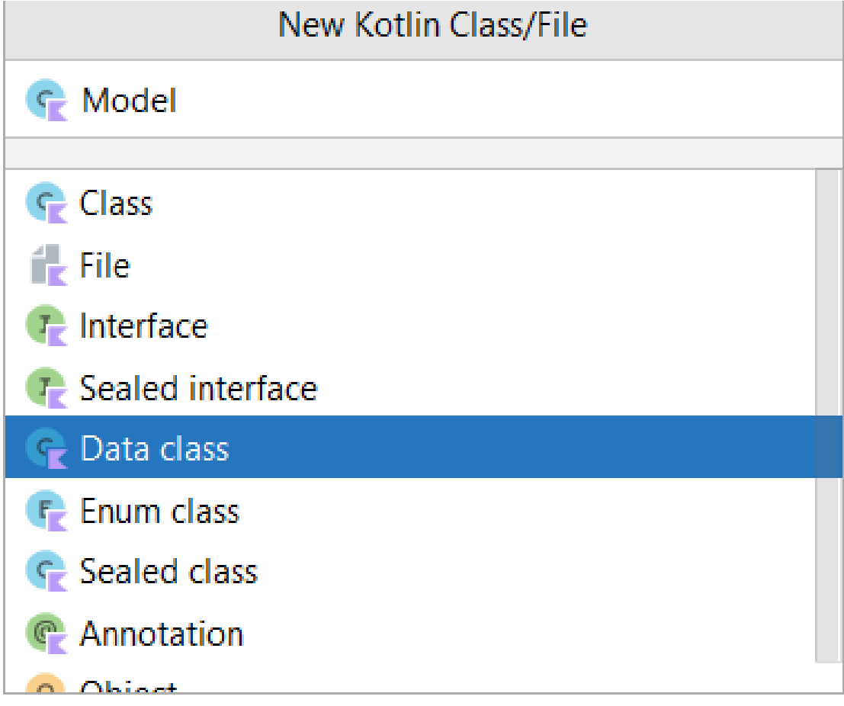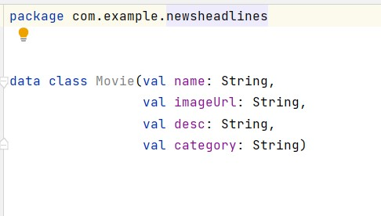

Model class code:

[https://github.com/smartinternz02/NewsHeadlines/tree/main/app/src/main/java/com/exa mple/newsheadlines/Model.kt](https://github.com/smartinternz02/NewsHeadlines/tree/main/app/src/main/java/com/example/newsheadlines/Model.kt)

Step 5:

Create News data class

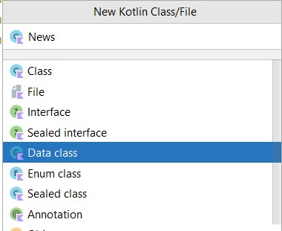

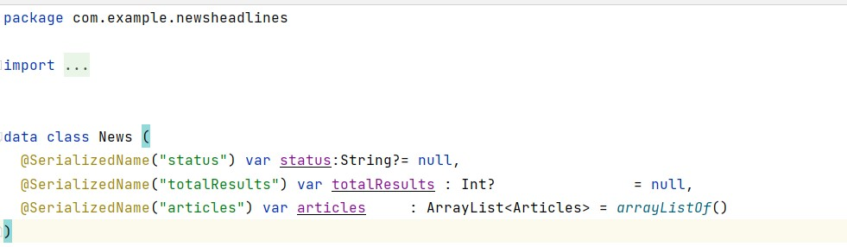

News class code:

[https://github.com/smartinternz02/NewsHeadlines/tree/main/app/src/main/java/com/exa mple/newsheadlines/News.kt](https://github.com/smartinternz02/NewsHeadlines/tree/main/app/src/main/java/com/example/newsheadlines/News.kt) Step 6:

Create Source data class

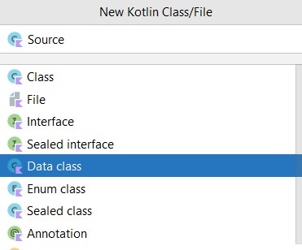

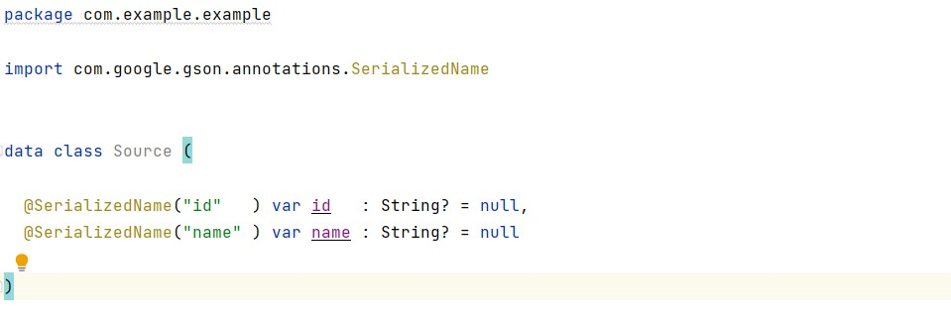

Model class code:

[https://github.com/smartinternz02/NewsHeadlines/tree/main/app/src/main/java/com/exa mple/newsheadlines/Source.kt](https://github.com/smartinternz02/NewsHeadlines/tree/main/app/src/main/java/com/example/newsheadlines/Source.kt) Step 7:

Create Articles data class

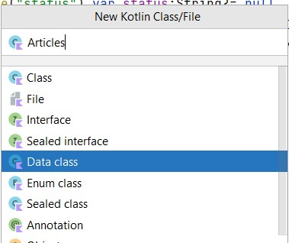

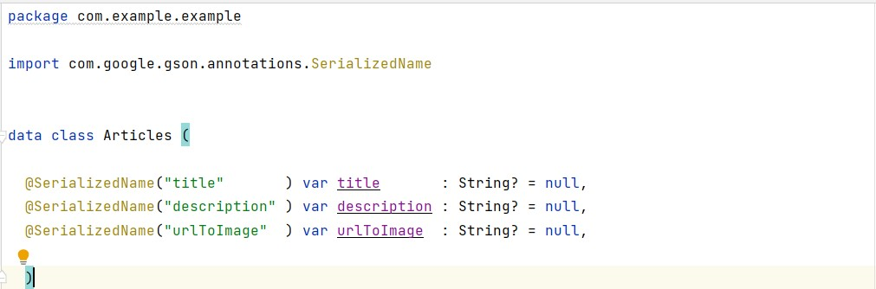

Article class code: [https://github.com/smartinternz02/NewsHeadlines/tree/main/app/src/main/java/com/exa mple/newsheadlines/Articles.kt](https://github.com/smartinternz02/NewsHeadlines/tree/main/app/src/main/java/com/example/newsheadlines/Articles.kt)

Step 8:

Create MainViewModel class

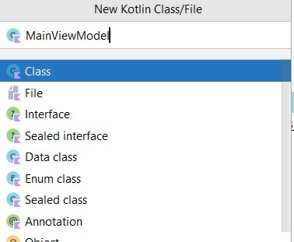

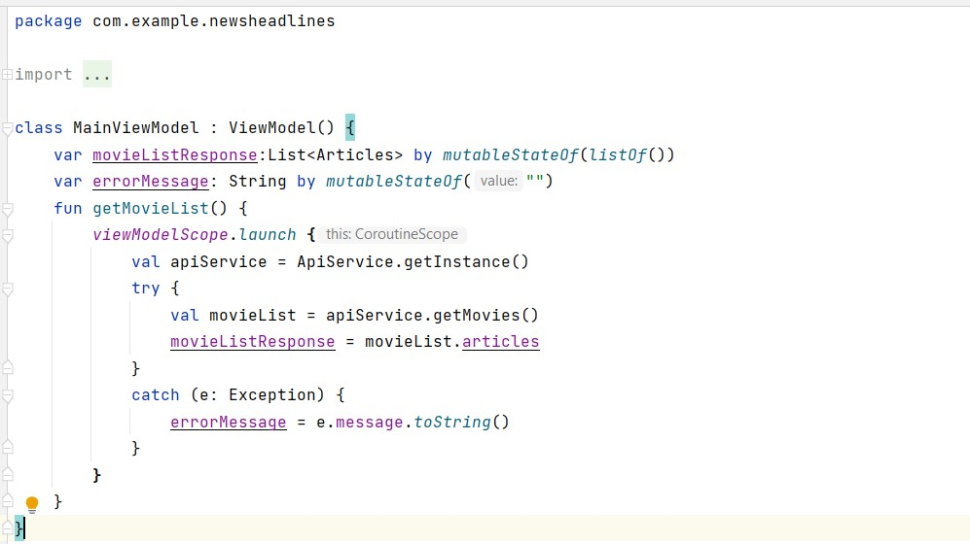

MainViewModel class code:

[https://github.com/smartinternz02/NewsHeadlines/tree/main/app/src/main/java/com/exa mple/newsheadlines/MainViewModel.kt](https://github.com/smartinternz02/NewsHeadlines/tree/main/app/src/main/java/com/example/newsheadlines/MainViewModel.kt)

**Task 7:**

Building application UI and connecting to database.

Step 1: Creating LoginActivity.kt with database

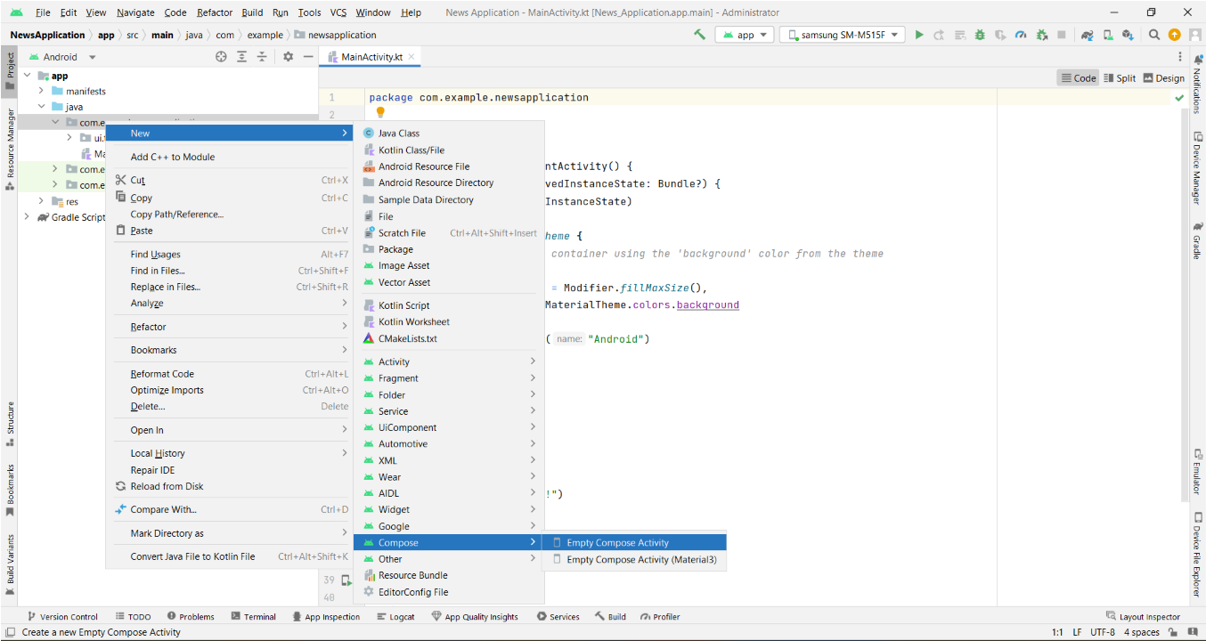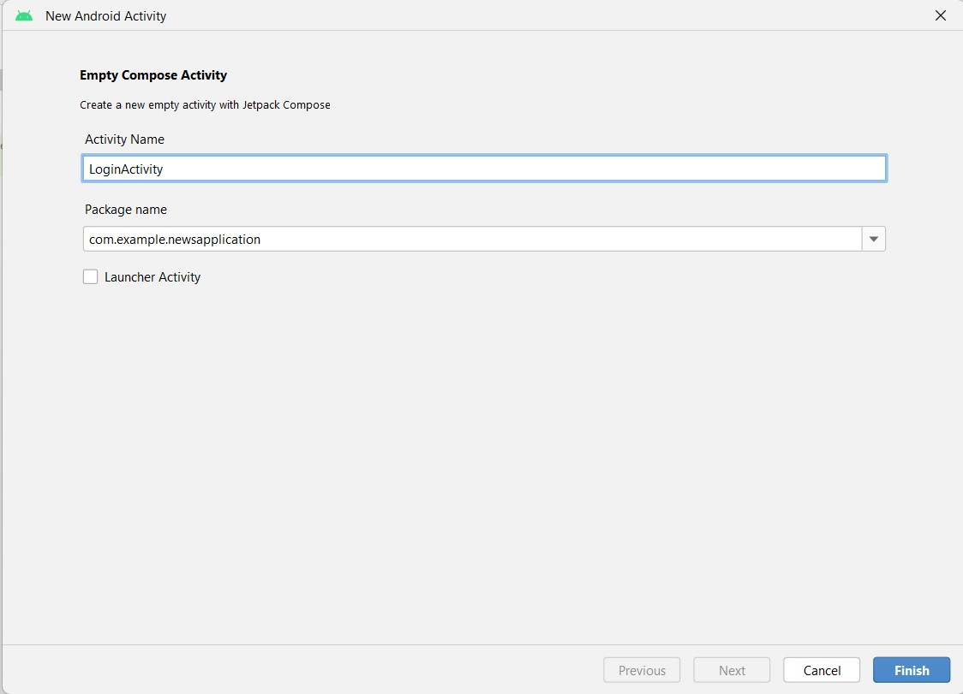

Database connection in LoginActivity.kt

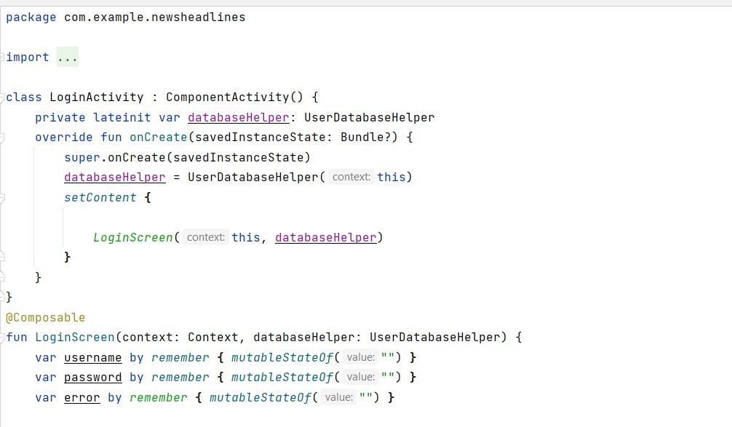

Complete code in below link [https://github.com/smartinternz02/NewsHeadlines/tree/main/app/src/main/java/com/exa mple/newsheadlines/LoginActivity.kt](https://github.com/smartinternz02/NewsHeadlines/tree/main/app/src/main/java/com/example/newsheadlines/LoginActivity.kt)

Step 2 : Creating RegistrationActivity.kt with database

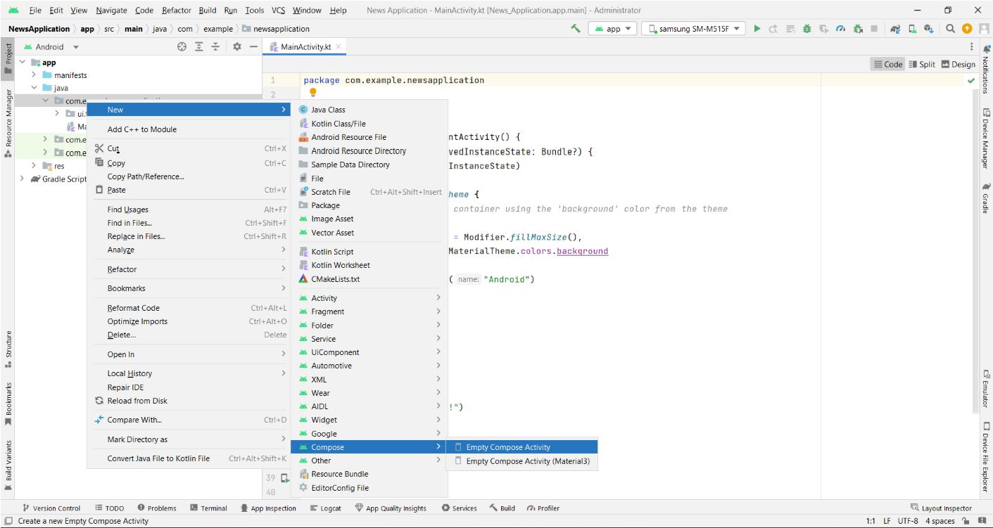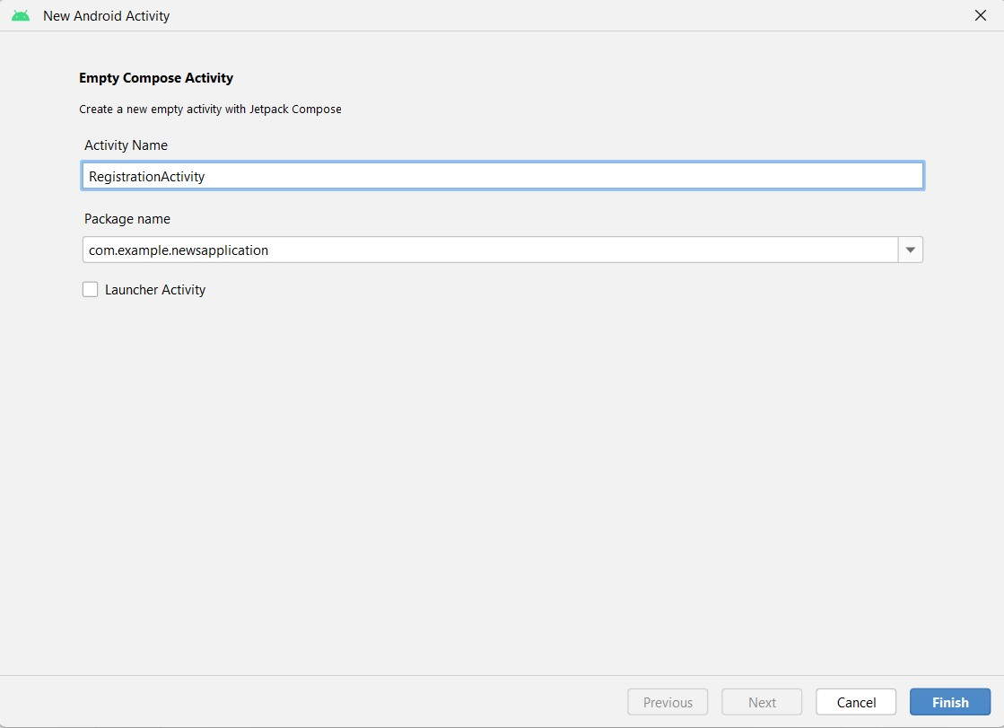

Database connection in RegistrationActivity.kt

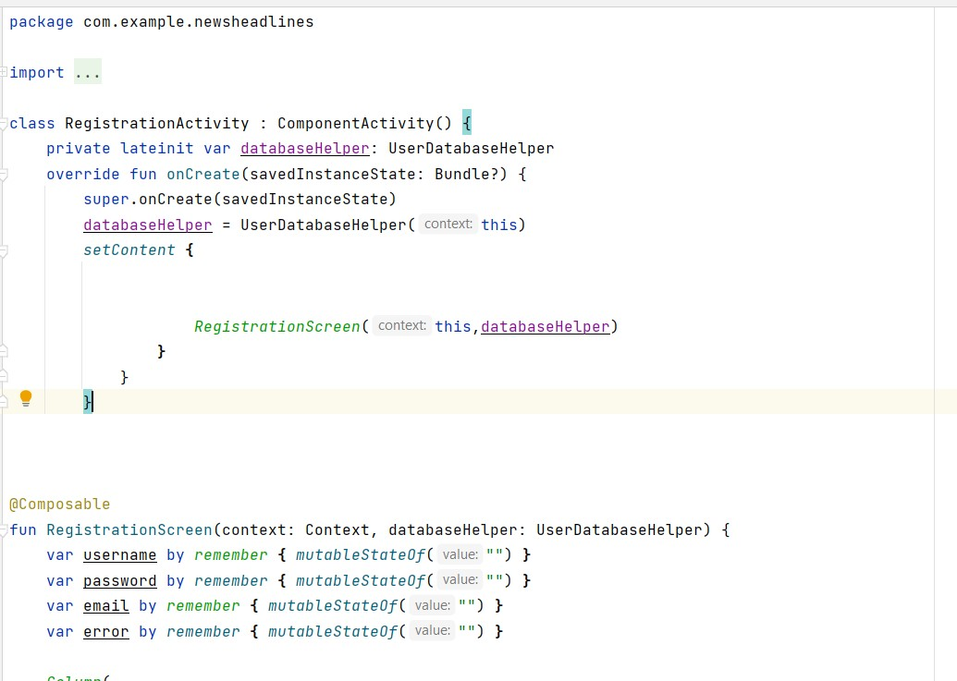

Complete code in below link:

[https://github.com/smartinternz02/NewsHeadlines/tree/main/app/src/main/java/com/exa mple/newsheadlines/RegistrationActivity.kt](https://github.com/smartinternz02/NewsHeadlines/tree/main/app/src/main/java/com/example/newsheadlines/RegistrationActivity.kt)

Step 3: Creating MainActivity.kt file

In MainActivity.kt file the main application is developed

* Before creating UI we need to add some images in drawables which are in res

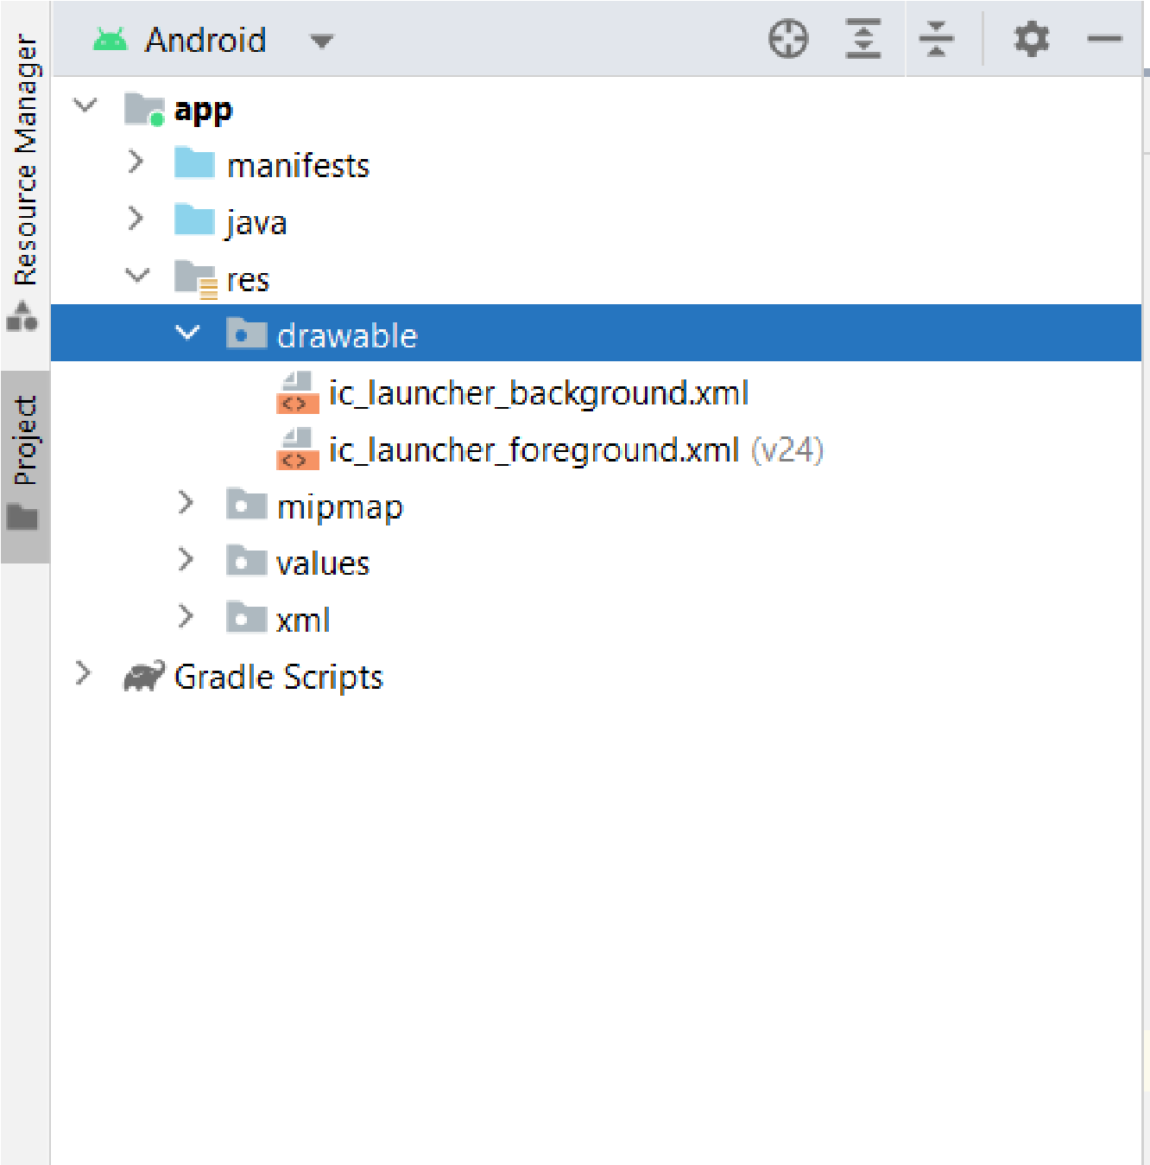

Download the required drawable from the code:

[https://github.com/smartinternz02/NewsHeadlines/tree/master/app/src/main/res/drawabl e](https://github.com/smartinternz02/NewsHeadlines/tree/master/app/src/main/res/drawable)

Download the nodpi images from drawablenodpi:

[https://github.com/smartinternz02/NewsHeadlines/tree/master/app/src/main/res/drawabl e-nodpi](https://github.com/smartinternz02/NewsHeadlines/tree/master/app/src/main/res/drawable-nodpi)

Required drawables

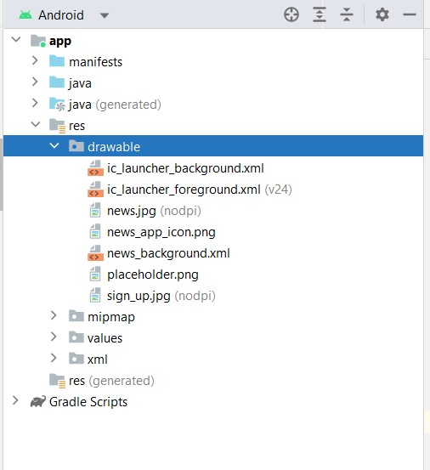

* After add all this we need to create the UI in MainActivity.kt file

Mainpage.kt file

Complete MainActivity.kt code: [https://github.com/smartinternz02/NewsHeadlines/blob/main/app/src/main/java/com/exa mple/newsheadlines/MainPage.kt](https://github.com/smartinternz02/NewsHeadlines/blob/main/app/src/main/java/com/example/newsheadlines/MainPage.kt)

Linking MainActivity with DisplayNews.kt

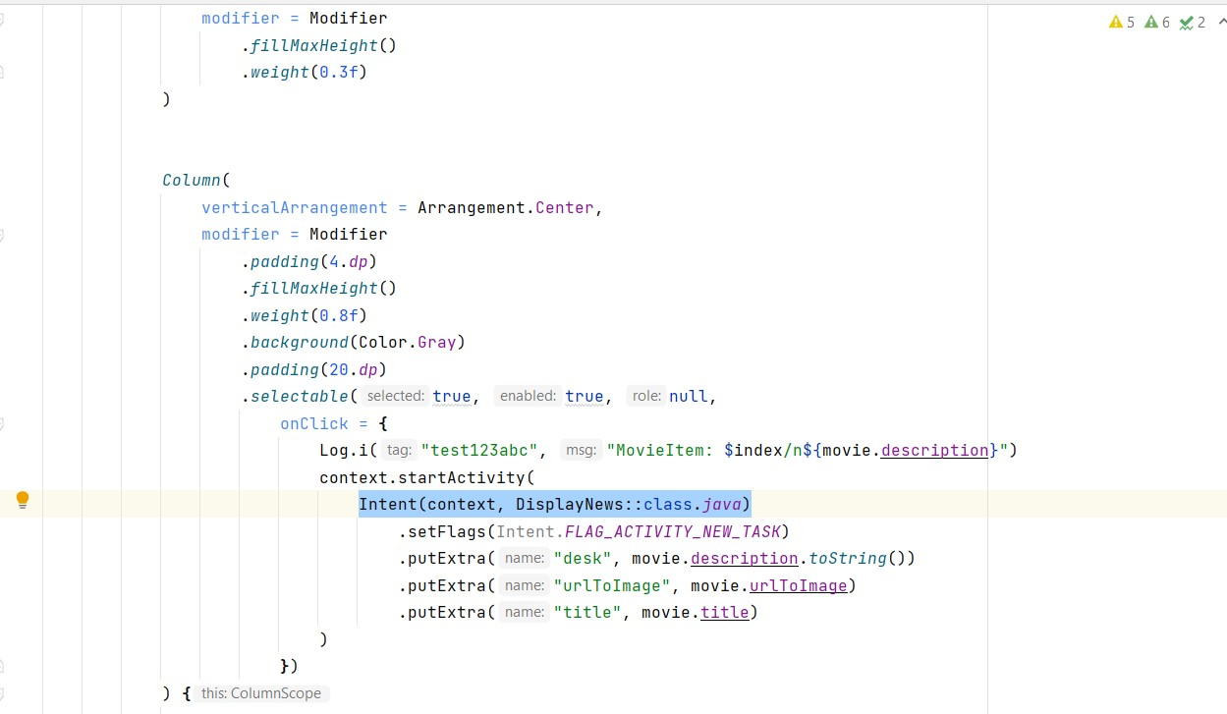

Step 4 : Creating DisplayNews.kt file

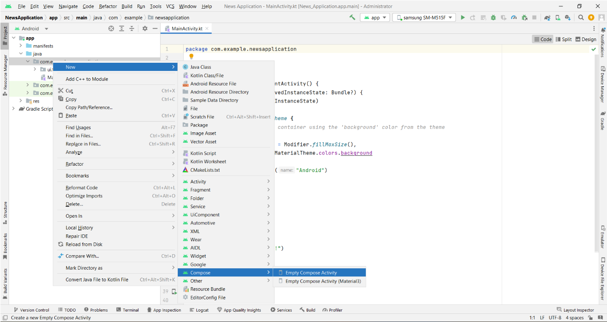

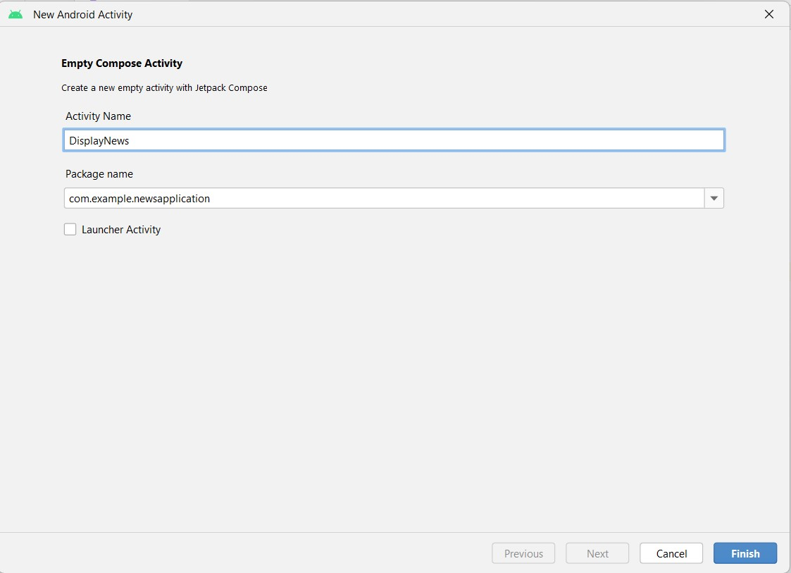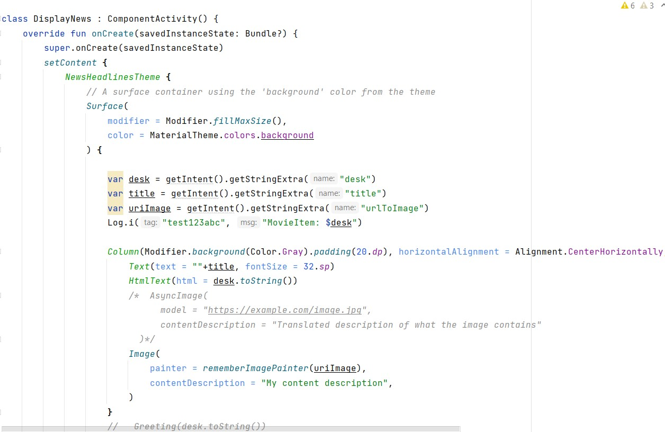

Complete DisplayNews.kt code:

[https://github.com/smartinternz02/NewsHeadlines/blob/main/app/src/main/java/com/exa mple/newsheadlines/DisplayNews.kt](https://github.com/smartinternz02/NewsHeadlines/blob/main/app/src/main/java/com/example/newsheadlines/DisplayNews.kt)

**Task 8:**

Modifying AndroidManifest.xml



When we run the app we will get the MainActivity.kt file as our first screen , but we want LoginActivity.kt , So we need to change in AndroidManifest.xml.

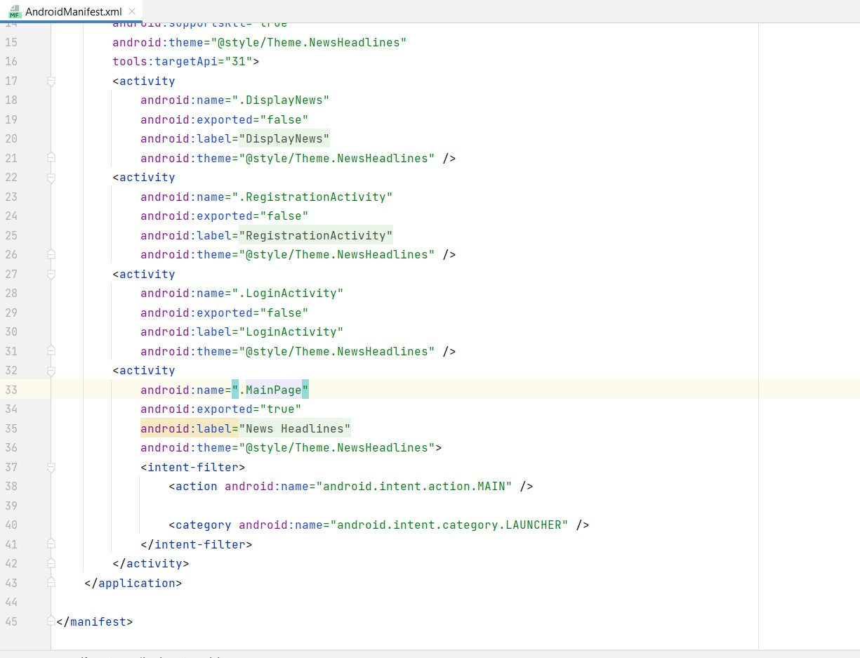

Changed AndroidManifest.xml.

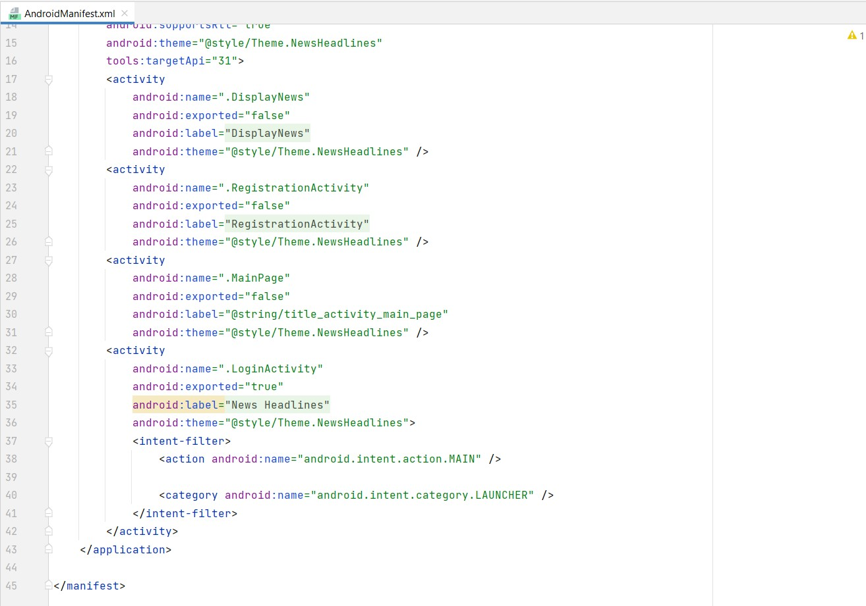

Complete code is given below:

[https://github.com/smartinternz02/NewsHeadlines/blob/master/app/src/main/AndroidMa nifest.xml](https://github.com/smartinternz02/NewsHeadlines/blob/master/app/src/main/AndroidManifest.xml)

**Task 9:**

Running the application.

Step 1: Run apps on a hardware device

<https://developer.android.com/studio/run/device>

Step 2: Run the application in Mobile

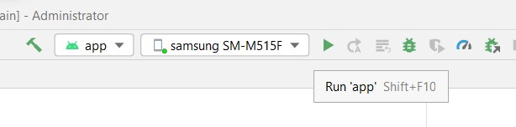

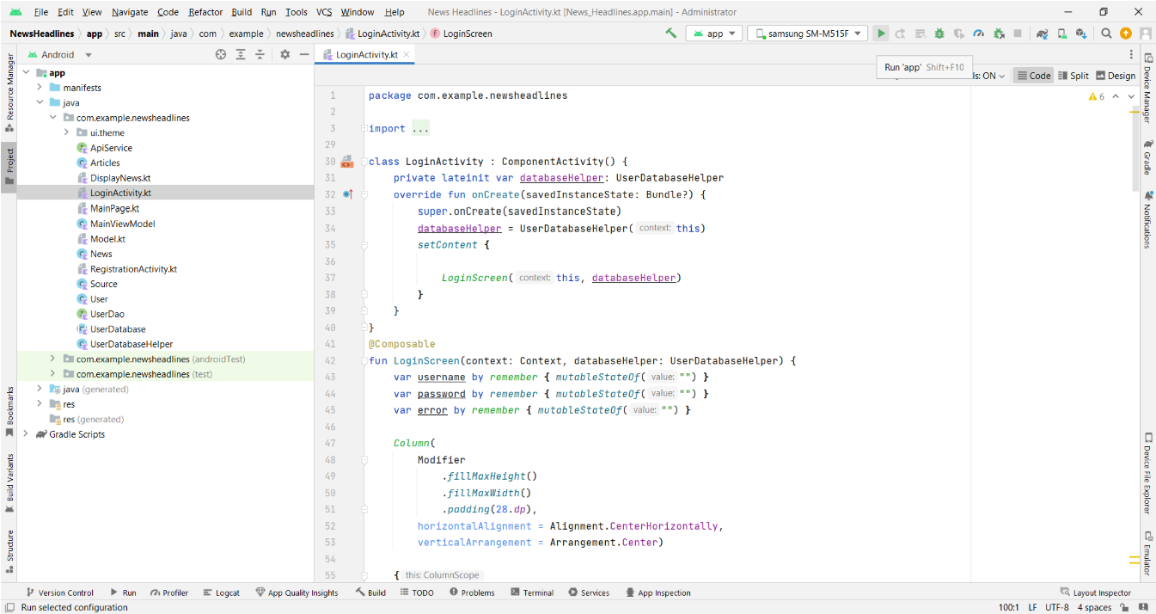

# Complete Project Link: <https://github.com/smartinternz02/NewsHeadlines>

**Final Output of the Application :**

Login Page:

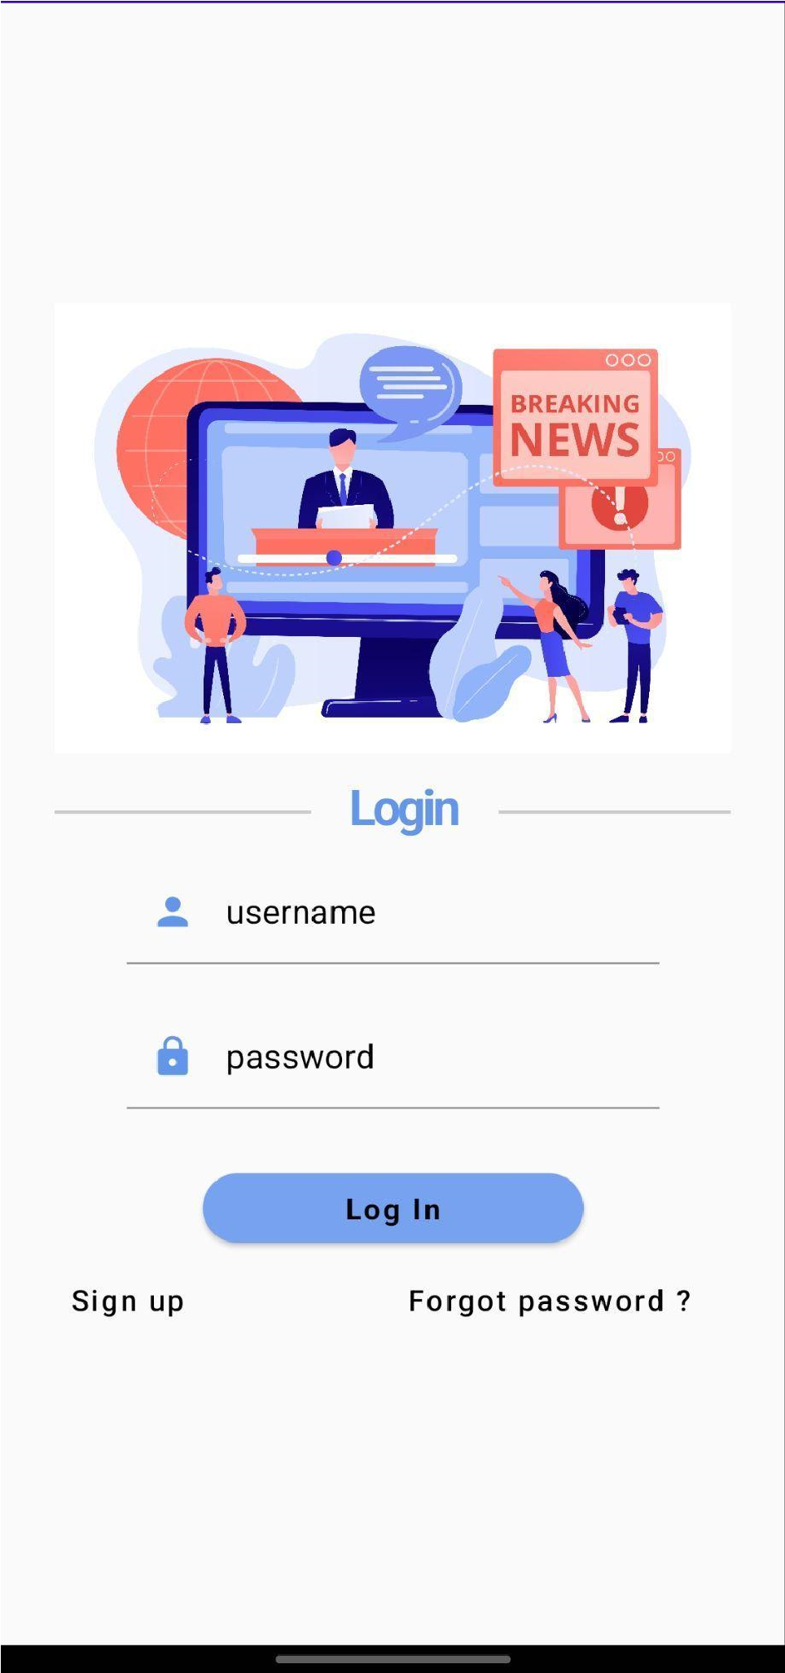

Register Page :

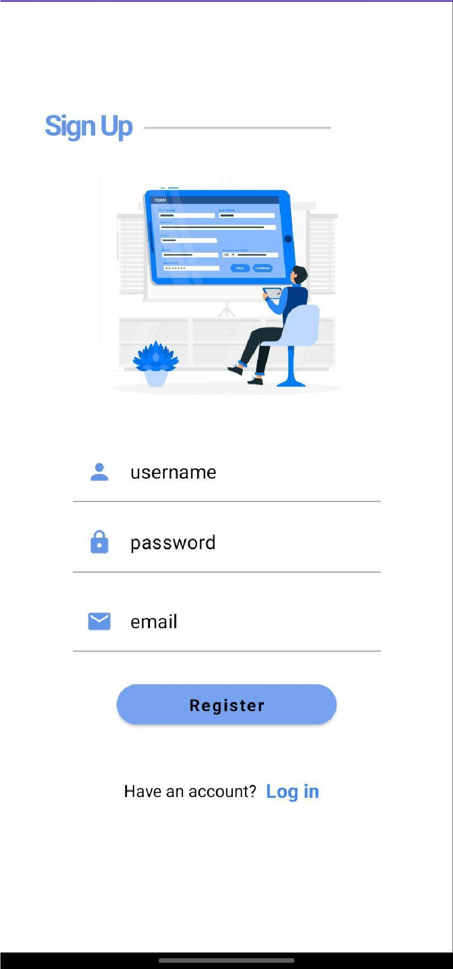

Main News Headlines Page:



Display News Page:

